Movie-Ticket Booking Application

Abstract

Our application is designed to help the user book movie tickets in a user friendly and secured platform. The design of the website proceeds through a sequence of well-designed forms provided with validations to ensure reliability and most importantly correctness of information.

The user is allowed to make new registration, select movies, can view the number of seats available etc.

The administrator is responsible for providing the correct information in every field.

The salient feature of BookerT(our Website) it brings theatre closer to the user for booking movie tickets.

**Contents**

1. **ABSTRACT**
2. **High level Design**
3. **System Configuration**
4. **Activity Diagram**
5. **Conclusion**

**High level design document**

* The application is created in java language.
* Spring framework is used
* JPA Hibernate is used for Database access
* For front-end we have used JSP,CSS and for back-end spring,hibernate is used.

**System configuration**

# H/W System Configuration :

|  |  |
| --- | --- |
| Processor | Intel i5 CPU |
| Speed | 3.30 GHz |
| RAM | 8 GB |
| System | 64 bit OS |
| Key Board | Standard Windows Keyboard |
| Monitor | SVGA |

# S/W Configuration :

|  |  |
| --- | --- |
| Operating System | Windows 10 |
| Web Server | Tomcat 8 |
| Front End | HTML, JSP |
|  |  |
| Server side | SpringMVC, Hibernate, JdbcTemplate |
| Database | Oracle |
| DB Connectivity | Hibernate |

Programming language will be Java so that configurations can be easily changed if necessary.

**Activity diagram of the system:**

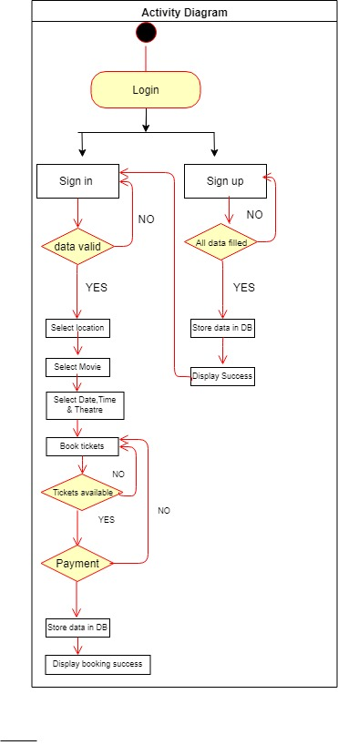

Conclusion**:**

In our project: with this movie ticketing system; cinema companies can satisfy comfortable facilities to their customers. The relationship between cinema manager, employee, and customer satisfy a good communication to complete ticketing process. With this platform we developed, we are hoping to reduce time wasting, avoid misunderstandings, provide easy data flow, customer pleasure, and less hard work. We believe that we have accomplished our goals and satisfied with the code we developed.